McKenzie Payne

Week 7 and 8 Assignment

1 heat map, 1 spatial chart and 1 lollipop chart using Tableau or PowerBI

1 heat map, 1 spatial chart and 1 lollipop chart using Python

1 heat map, 1 spatial chart and 1 lollipop chart using R

Using R:

Heat Map:

*# Load required libraries*

library(gplots)

library(readr)

ppg_csv **<-** "C:/Users/mcken/OneDrive/Documents/ppg2008.csv"

*# Load data*

ppg_df **<-** read_csv(ppg_csv)

*# Plotting heat map*

heatmap(as.matrix(ppg_df[, c("PTS", "AST", "TRB")]), scale**=**"column",

Rowv**=NA**, Colv**=NA**, margins**=**c(5,10),

xlab**=**"Statistics", ylab**=**"Players",

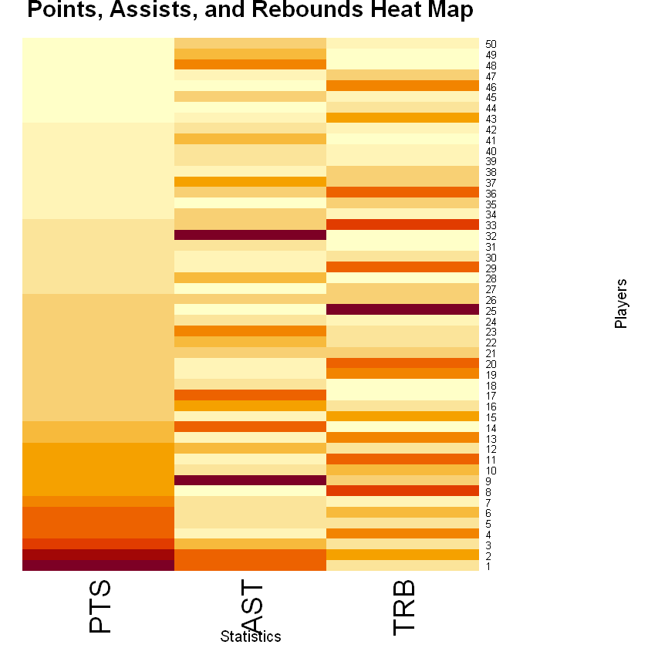

Spatial Chart:

*# Load required libraries*

library(ggplot2)

library(readr)

costcos_csv **<-** "C:/Users/mcken/OneDrive/Documents/costcos-geocoded.csv"

*# Load data*

costcos_df **<-** read_csv(costcos_csv)

*# Plotting spatial chart*

ggplot(costcos_df, aes(x**=**Longitude, y**=**Latitude)) **+**

geom_point(color**=**"blue") **+**

ggtitle("Costco Locations Spatial Chart") **+**

xlab("Longitude") **+** ylab("Latitude")

**\**

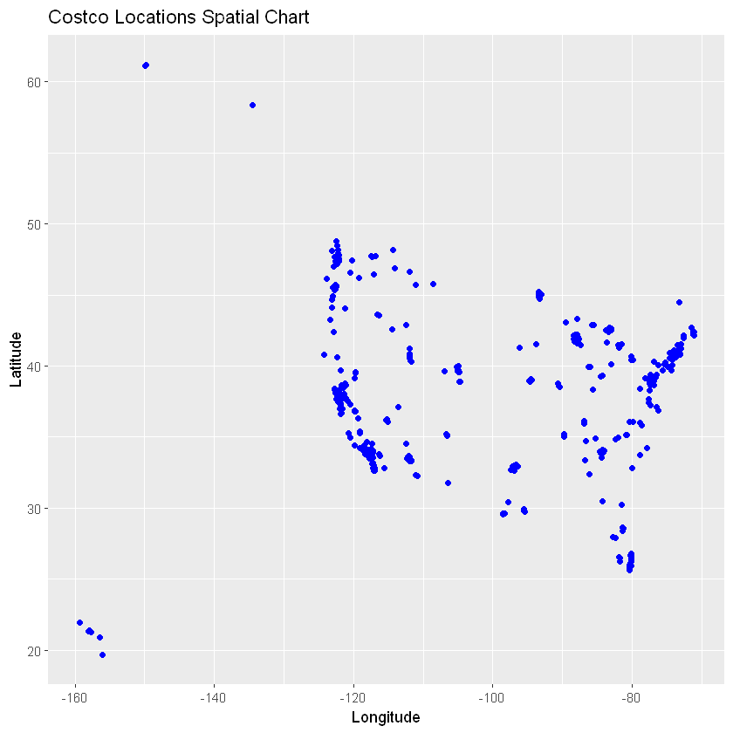

Lollipop Chart:

top_players **<-** head(ppg_df**$**Name, 5)

top_points **<-** head(ppg_df**$**PTS, 5)

*# Create data frame*

top_players_df **<-** data.frame(Player**=**top_players, Points**=**top_points)

*# Plotting lollipop chart*

ggplot(top_players_df, aes(x**=**Player, y**=**Points)) **+**

geom_point(color**=**"red", size**=**3) **+**

geom_segment(aes(x**=**Player, xend**=**Player, y**=**0, yend**=**Points), color**=**"grey") **+**

ggtitle("Top Players Points per Game (PPG) Lollipop Chart") **+**

xlab("Player") **+** ylab("Points")



*************************************************************************************

Using Python:

Heat Map:

**import** pandas **as** pd

**import** matplotlib.pyplot **as** plt

**import** seaborn **as** sns

*# Load the data with correct column names*

costcos_df **=** pd**.**read_csv("C:\\Users\\mcken\\OneDrive\\Documents\\costcos-geocoded.csv")

*# Create a heat map*

plt**.**figure(figsize**=**(10, 8))

sns**.**scatterplot(x**=**'Longitude', y**=**'Latitude', data**=**costcos_df, palette**=**'viridis')

plt**.**title('Costco Locations Heat Map')

plt**.**xlabel('Longitude')

plt**.**ylabel('Latitude')

plt**.**show()

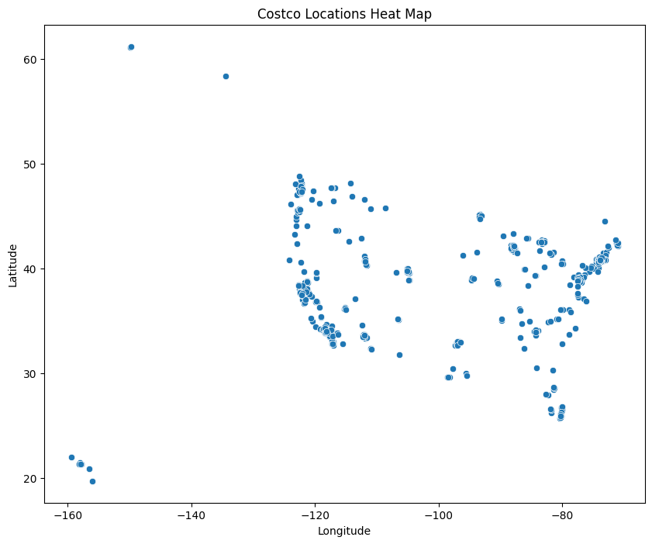

Spatial Chart:

**import** geopandas **as** gpd

**import** matplotlib.pyplot **as** plt

**import** contextily **as** cx

*# Assuming gdf is your GeoDataFrame with correct CRS set*

fig, ax **=** plt**.**subplots(figsize**=**(10, 10))

gdf**.**plot(ax**=**ax, color**=**'red', markersize**=**5)

*# Check if CRS is set and then add basemap*

**if** gdf**.**crs:

**try**:

cx**.**add_basemap(ax, crs**=**gdf**.**crs**.**to_string(), source**=**cx**.**providers**.**Stamen**.**TonerLite)

**except** Exception **as** e:

print(f"Error adding basemap: {e}")

**else**:

print("CRS is not set for the GeoDataFrame.")

plt**.**title("Spatial Chart Title")

plt**.**show()

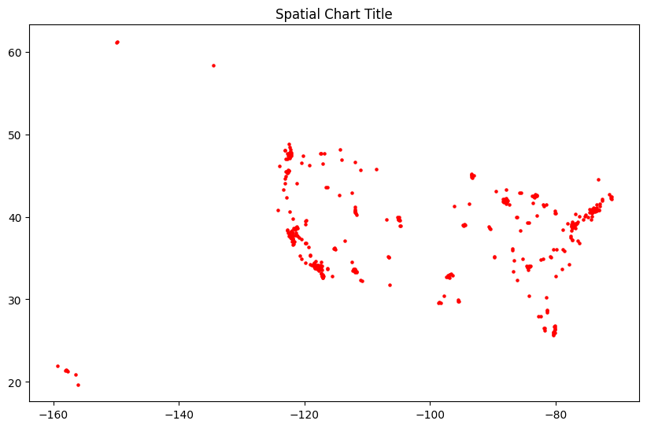

Lollipop Chart:

**import** pandas **as** pd

**import** matplotlib.pyplot **as** plt

*# Load the data*

ppg_df **=** pd**.**read_csv("C:\\Users\\mcken\\OneDrive\\Documents\\ppg2008.csv")

*# Sort the dataframe by 'PTS' column*

ppg_df**.**sort_values(by**=**'PTS', inplace**=True**)

*# Create a lollipop chart*

plt**.**figure(figsize**=**(10, 6))

plt**.**stem(ppg_df['Name '], ppg_df['PTS'], linefmt**=**'grey', markerfmt**=**'D', basefmt**=**' ')

plt**.**xticks(rotation**=**90)

plt**.**xlabel('Player')

plt**.**ylabel('Points per Game')

plt**.**title('Points per Game in 2008')

plt**.**tight_layout()

plt**.**show()

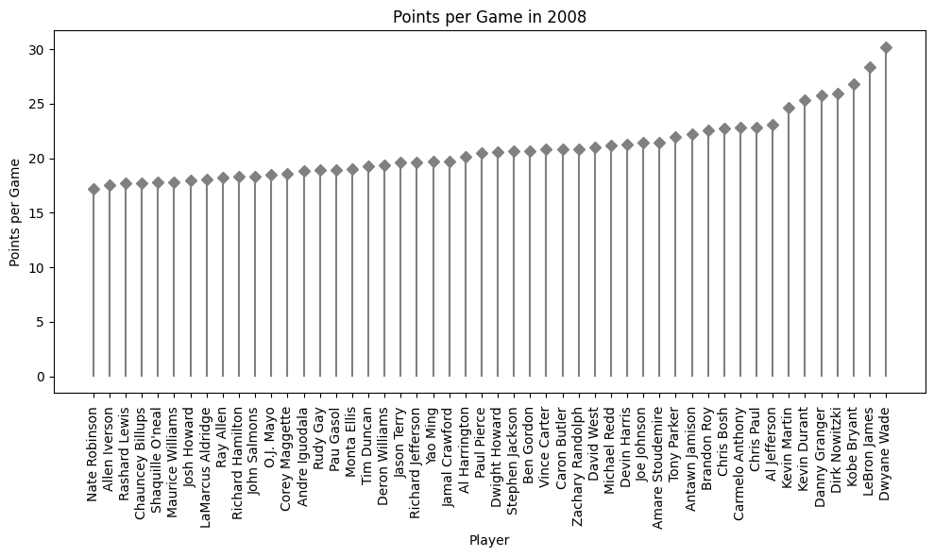

In [ ]:

*****************************************************************************

Power BI:

Heat Map:

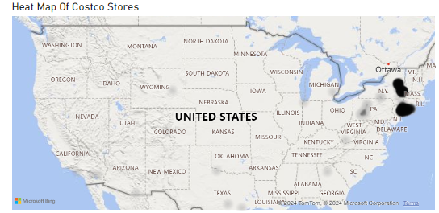

Spatial Chart:

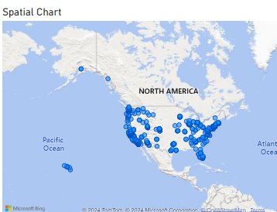

Lollipop Chart:

